

**CHRIST VisitorPass**

**SRS Report**

By

Aaron Mathew Shaji (2247201)

 Apoorva Vasishtha (2247240*)*

 Mohit Mehta (2247267)

Under the guidance of

Dr. Kavitha R

February – 2023

**Use Case Diagram**

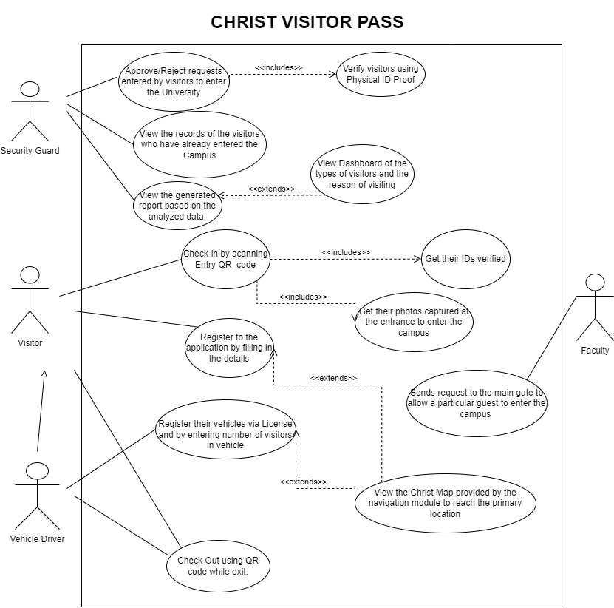

The Security Guard can approve or reject the request made by the Visitors for entry to the university. The guard also verifies the visitors through their ID Proofs. They can also check all the people who have entered the university along with their details. Furthermore, the can view the generated reports, which provide the security with valuable information on visitor activity. The Navigation component, managed by the same guards(admin) will basically reflect the analysis of all the people who have visited during any selected period of time and for what purpose. This is basically to get a report of all the people visiting the university in a graphical and easy-to-understand manner.

A visitor coming to the university for any purpose need to scan a QR code, redirecting to the registration webpage, and make an entry on the app giving every detail about them along with their Photo (captured via the camera). After this process is completed and details submitted, it will get reflected in the security guard’s tab for approval. The visitor’s ID is also verified. To check out. there will be a QR Code placed at the entrance beside Entry QR Code, scanning which they can check out from the college. They can also use the Christ Map navigation to guide them the path to their destination.

In the case of a visitor coming through vehicle, the driver of the vehicle needs to make an entry about the number of people visiting and everyone’s respective details, along with the license number.

Additionally, the Faculty can send a request to the Main Gate that they are expecting a person for this certain purpose.

**DFD (Data Flow Diagram)**

**Level 0**

At level 0, the DFD would depict a broad view that is easily digestible but offering little detail.

Here the primary external entity would be the visitor who interacts with the system, the main process would likely be "Christ Visitor Pass" which represents the overall system that manages visitors, as well as any identification or security information that may need to be collected. Also there would be one more external entity Faculty which will help us to create visitor request directly.

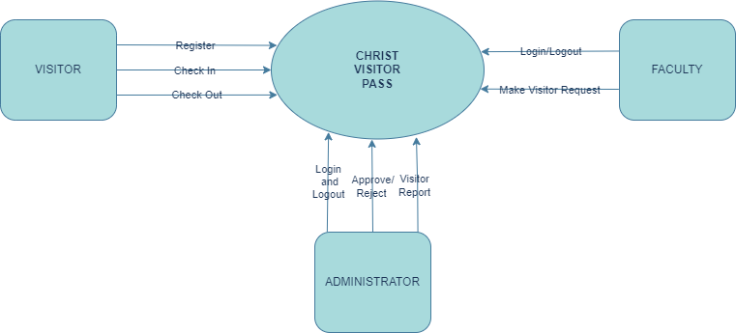

**Level 1 (Visitor Module)**

At level 1 of the data flow diagram for the visitor module of a visitor management system, we would expand the "Christ Visitor Pass" process from level 0 into more detailed sub-processes. The Visitor Entry process would be broken down into several sub-processes, such as Visitor Registration, Navigation, Visitor Check-Out, and Getting Virtual ID.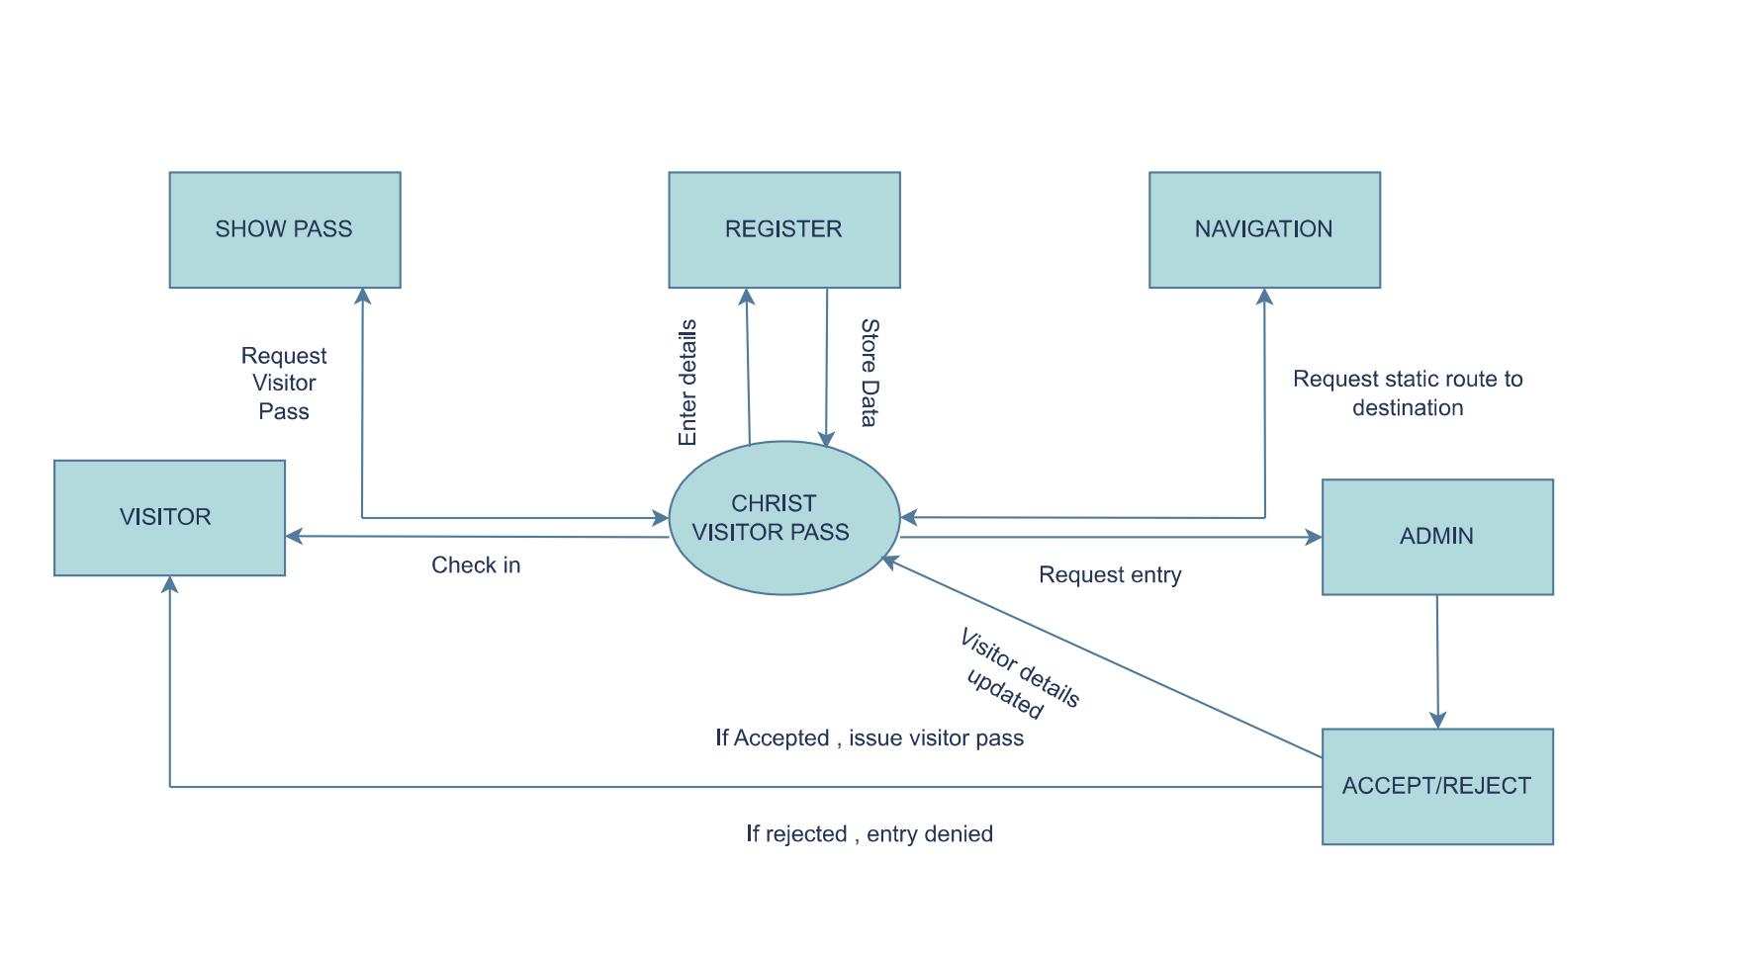

The Visitor part of the data flow diagram in a Visitor Management System includes the processes involved in managing the arrival, registration, and departure of visitors. This includes capturing visitor information such as name, contact information, and purpose of visit. It also includes verifying the identity of the visitor and issuing a visitor badge or pass.

Additionally, the Visitor part of the data flow diagram may include processes for generating reports on visitor activity. This can be useful for security and compliance purposes.

**Level 1 (Admin Module)**

At level 1 of the data flow diagram for the admin module of a Christ Visitor Pass, we would expand the "Christ Visitor Pass" process from level 0 into more detailed sub-processes. The Entry process would be broken down into several sub-processes, such as Visitor List, Visitor Check-In Approval, Visitor Check-Out Report, Dashboard, and Admin Settings.

